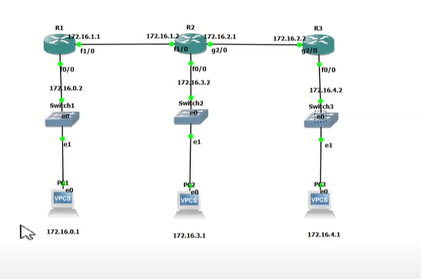

**OSPF**

**R1**

configure terminal

Interface f0/0

Ip address 172.16.0.2 255.255.255.0

no shut

exit

inter f1/0

ip address 172.16.1.1 255.255.255.0

no shut

exit

router ospf 100

network 172.16.0.0 0.0.0.255 area 0

network 172.16.1.0 0.0.0.255 area 0

#exit

Exit

**R2**

Config t

inter fa0/0

ip address 172.16.0.2 255.255.255.0

no shut

exit

inter g2/0

ip address 172.16.2.1 255.255.255.0

no shut

exit

router ospf200

network 172.16.1.0 0.0.0.255 area 0

network 172.16.2.0 0.0.0.255 area 0

network 172.16.3.0 0.0.0.255 area 0

exit

**R3**

exit

inter f0/0

ip address 172.16.4.2 255.255.255.0

no shut

exit

inter g2/0

ip address 172.16.2.2 255.255.255.0

no shut

exit

router ospf 300

network 172.16.2.0 0.0.0.255 area 0

network 172.16.4.0 0.0.0.255 area 0

**PC1**

ip172.16.0.1/24 172.16.0.2

**PC2**

ip172.16.3.1/24 172.16.3.2

**PC1**

ip172.16.4.1/24 172.16.4.2